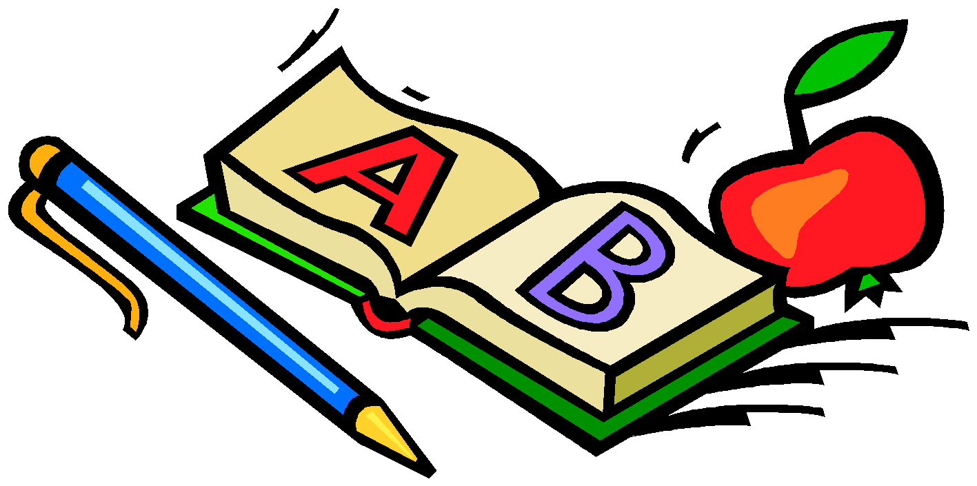

Kindergarten Supply List

2023 - 2024

All supplies should be labeled with your child’s name and sent in the first day of school.

* Smock for Art Class

Please send an oversized t-shirt to help protect your child’s clothing. No button-down shirts or plastic aprons, please. The art smock should be in a large Ziploc bag labeled with your child’s name. Also, please write his/her name on the inside of the shirt.

* 1 black and white composition notebook
* 1 box of Crayola crayons, 24 count
* 4 black Expo dry erase markers (low odor)
* 6 large glue stick
* Girls Only – 1 box of sandwich size Ziploc bags
* Boys Only – 1 box of gallon size Ziploc bags
* Headphones in labeled Ziploc bag

Optional:

1 package of baby wipes/1 box of facial tissues

Thank you for your support!